Size Data: WYATT Stars and Stripes

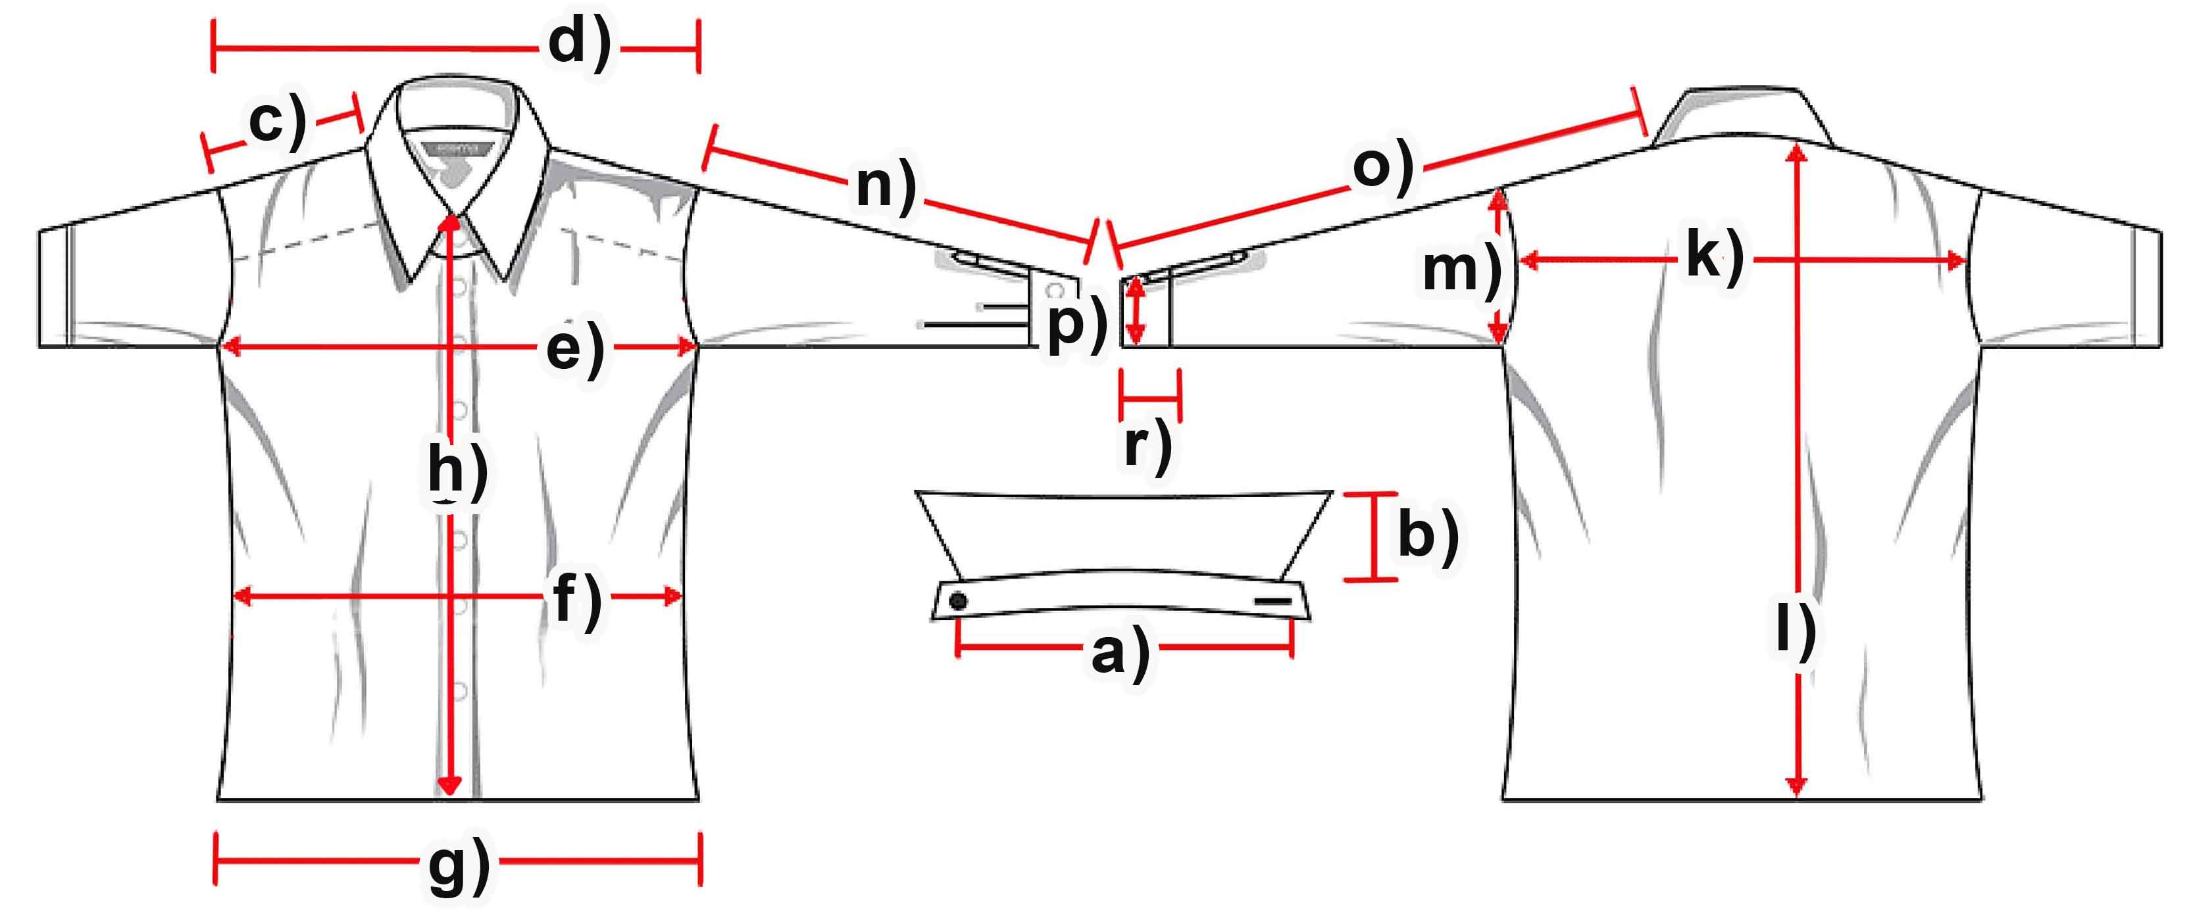

Mass (cm) | XS | S | M | L | XL | XXL | 3XL
a) collar width
b) collar height
c) shoulder |  | 14,5 | 15 | 15,5 | 16 | 16,5 | 17
d) shoulder complete |  | 46,5 | 49 | 51 | 52,5 | 54,5 | 56
e) chest |  | 54,5 | 57 | 60 | 63 | 65 | 67,5
f) waist |  | 51 | 53 | 56 | 59 | 62 | 65
g) hemline
h) button-facing
k) back |  | 42,5 | 45 | 46,5 | 48,5 | 50 | 51,5
l) length
m)armhole
n) armlength |  | 63 | 65,5 | 67 | 68,5 | 71 | 72,5
o) arm + shoulder |  | 77,5 | 80,5 | 82,5 | 84,5 | 87,5 | 89,5
p) cuff width
r) cuff height

