Size data: SAVANNAH

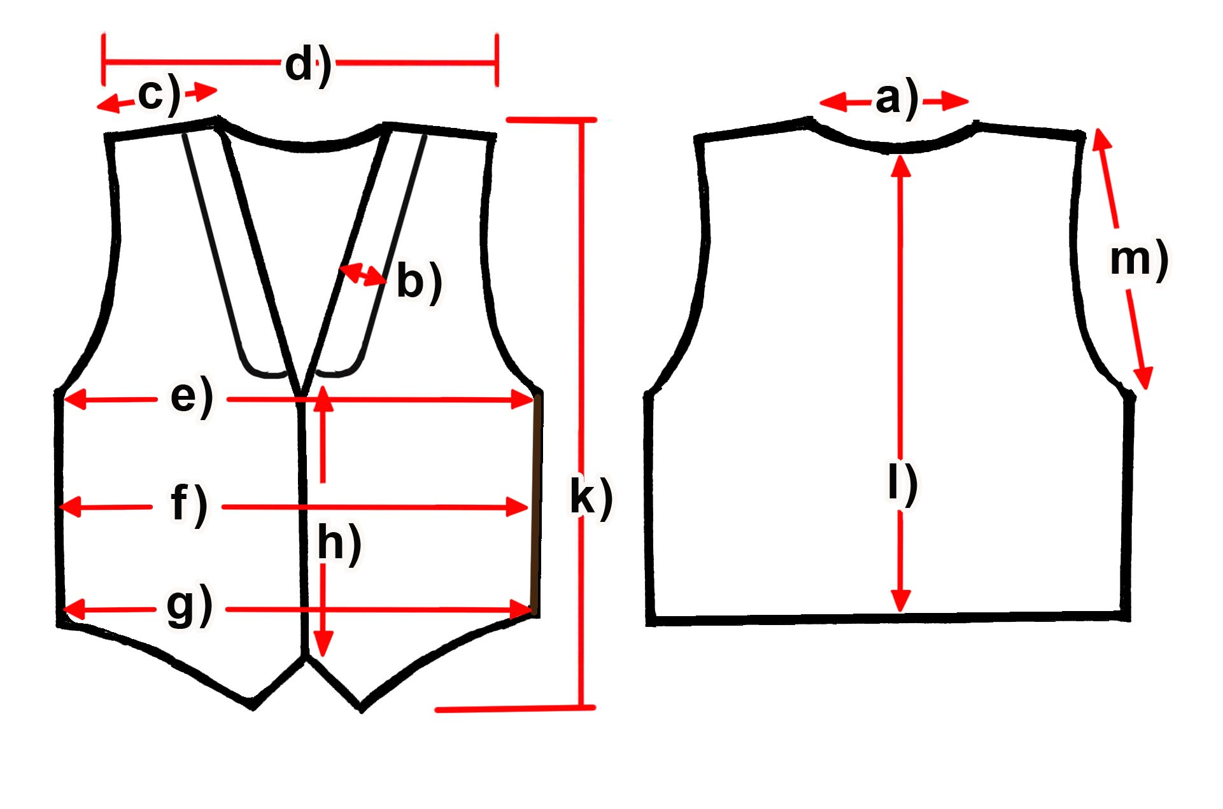

Measure (cm) | S | M | L | XL | XXL | 3XL
a) Neck
b) Collar width
c) Shoulder | 11,5 | 11,5 | 12 | 12 | 13,5 | 14,5
d) Shoulders total | 37,5 | 38 | 39,5 | 41 | 43,5 | 44
e) Chest | 47 | 49,5 | 51,5 | 54 | 57,5 | 59
f) Waist | 41,5 | 43,5 | 45,5 | 48,5 | 52 | 52,5
g) Hem | 43 | 45 | 47 | 50 | 53,5 | 55
h) Placket | 26,5 | 27,5 | 28 | 29 | 30 | 31
k) Length front | 57 | 58,5 | 58,5 | 60 | 61 | 62
l) Length back | 53,5 | 55 | 55,5 | 57 | 58,5 | 59
m) Armhole | 20,5 | 21 | 21,5 | 22 | 23,5 | 25

