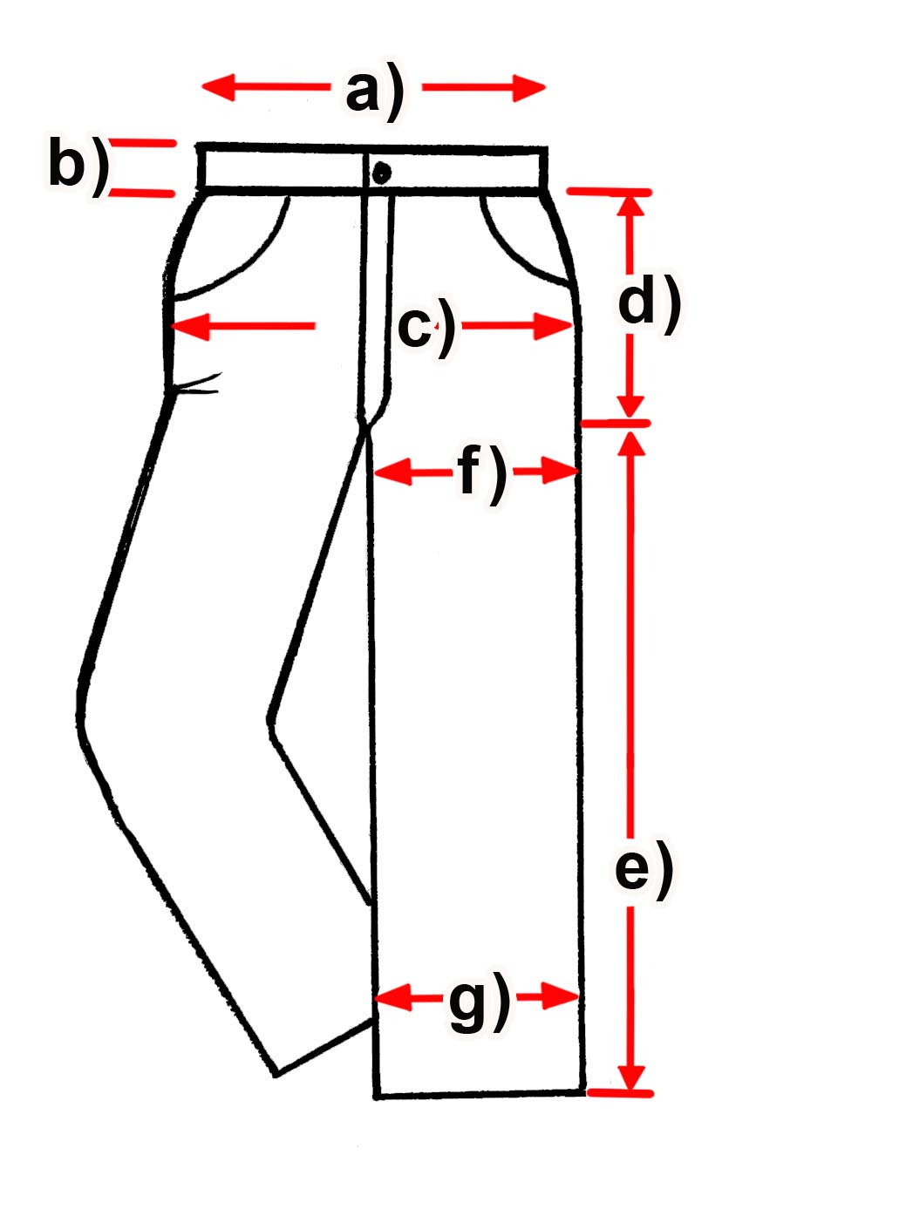
Measurements Trouser

SAMUEL all in INCH
Item: _

Date

Measure (inch) | 28 | 29 | 30 | 31 | 32 | 33 | 34
a) waist width |  | 15 | 15,75 | 16, | 16,5 | 16,5 | 17,5
b) waist height |  | 2 | 2 | 2 | 2 | 2 | 2
c) Hip width |  | 18,25 | 19,75 | 19,5 | 20,25 | 19,75 | 20,2
d +e) Length |  | 34  ,5 | 36,5 | 36,5 | 36,5 | 36,5 | 36,5
Measure (inch) | 36 | 38 | 40 | 42 | 44 | 46
a) waist width | 19 | 19,25 | 20,25 | 21 | 22 | 23
b) waist height | 1,9 | 2 | 1,8 | 1,8 | 1,5 | 1,5
c) Hip width | 21,5 | 22 | 24,25 | 24,5 | 25,5 | 26,25
d +e) Length | 36 | 36 | 36,5 | 36,75 | 36,25 | 36,5

Notes: all Infos in inch /// 1 inch = 2,54 cm

