**John**

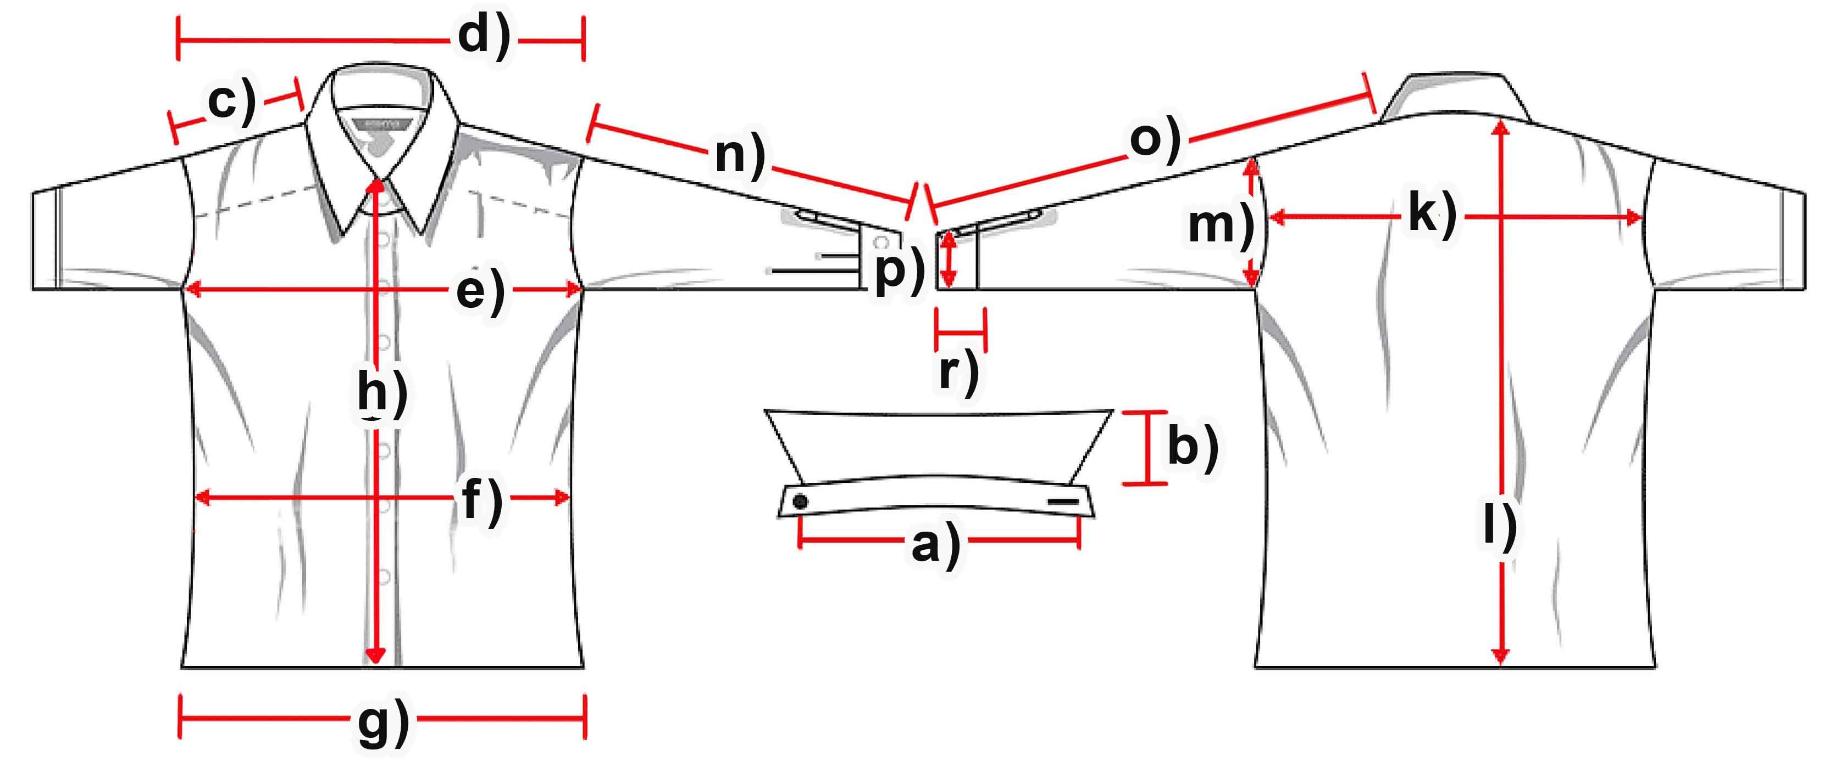

|  |  |  |  |  |  |  |  |  |
| --- | --- | --- | --- | --- | --- | --- | --- | --- |
| **Maße (cm)** | **XS** | **S** | **M** | **L** | **XL** | **XXL** | **3XL** |  |
| a) Kragenweite |  |  |  |  |  |  |  |  |
| b) Kragenhöhe |  |  |  |  |  |  |  |  |
| c) Schulter |  |  | **15** | **15** | **15,5** | **15,5** | **15,5** |  |
| d) Schultergesamt |  |  | **48** | **48,5** | **51** | **51,5** | **53,5** |  |
| e) Brust |  |  | **57** | **59** | **63** | **67** | **69** |  |
| f) Taille |  |  | **54** | **56,5** | **60** | **64** | **65** |  |
| g) Saum |  |  | **65,5** | **70,5** | **72,5** | **75** | **78** |  |
| h) Knopfleiste |  |  | **69** | **69** | **69** | **71,5** | **72,5** |  |
| k) Rückenbreite |  |  | **45** | **45,5** | **48,5** | **49,5** | **53** |  |
| l) Rumpflänge |  |  | **97,5** | **103,5** | **103,5** | **106** | **107** |  |
| m) Armloch |  |  | **31** | **32** | **32,5** | **34** | **34** |  |
| n) Armlänge |  |  | **66** | **68,5** | **70** | **74,5** | **75** |  |
| o) Arm + Schulter |  |  | **81** | **83,5** | **85,5** | **90** | **91,5** |  |
| p) Manschettenbreite |  |  | **15,5** | **16** | **16** | **16,5** | **16,5** |  |
| Vorder Länge |  |  | **101** | **103,5** | **105,5** | **110** | **110** |  |
|  |  |  |  |  |  |  |  |  |