JASON

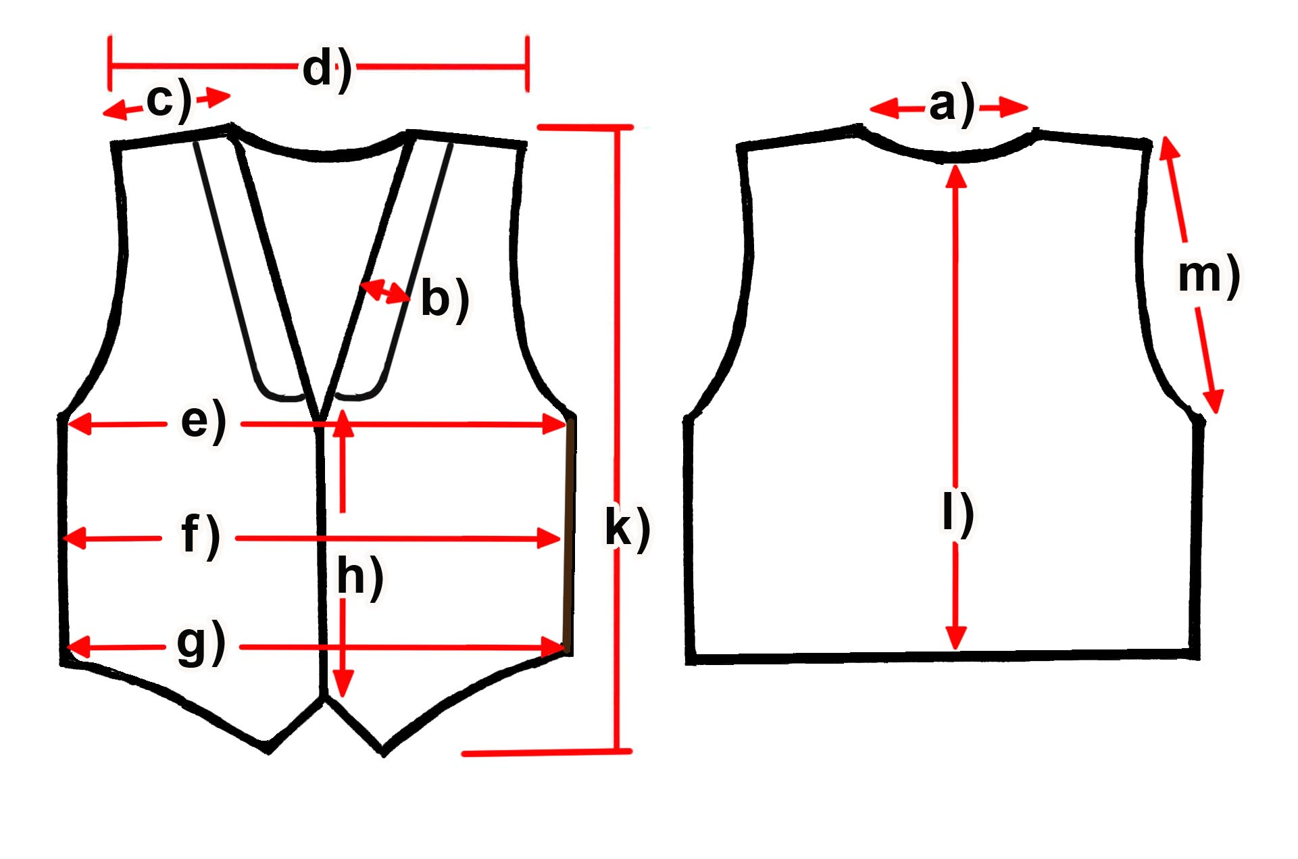

Measure (cm) | S | M | L | XL | XXL | 3XL
a) Neck | 16 | 16,5 | 16,5 | 17 | 17,5 | 18
b) Collar width
c) Shoulder | 12 | 12,5 | 13 | 14 | 14,5 | 15
d) Shoulders total | 40 | 41 | 42 | 43 | 44 | 45
e) Chest | 52,5 | 54,5 | 57 | 59 | 62 | 64
f) Waist | 50,5 | 53 | 55 | 56,5 | 58 | 61
g) Hem | 49 | 52 | 53,5 | 54,5 | 57,5 | 60
h) Placket | 28 | 28,5 | 28,5 | 29,5 | 30 | 31
k) Length front | 57 | 58,5 | 59,5 | 60,5 | 62 | 62
l) Length back | 51 | 52 | 53,5 | 55 | 56 | 57
m) Armhole | 25 | 26 | 27 | 27 | 28 | 28

