**GOLDFIELD**

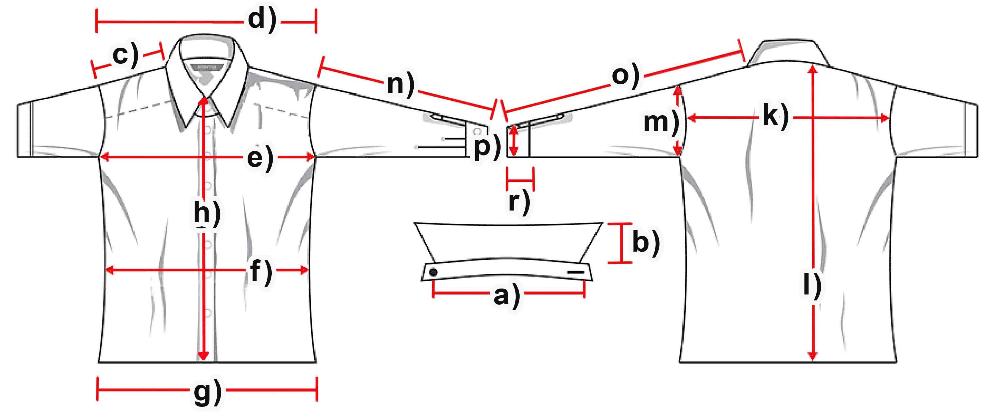

|  |  |  |  |  |  |
| --- | --- | --- | --- | --- | --- |
| **Mass (cm)** | **S** | **M** | **L** | **XL** | **XXL** |
| a) collar width | 53 | 53 | 55 | 55,5 | 58 |
| b) collar height | 12 | 12,5 | 12,5 | 12,5 | 12,5 |
| c) shoulder |  |  |  |  |  |
| d) shoulder complete | 75,5 | 77 | 81,5 | 82 | 85 |
| e) chest | 62,5 | 64,5 | 66 | 67,5 | 70 |
| f) waist | 61 | 63,5 | 65 | 67,5 | 70 |
| g) hemline | 61 | 63,5 | 65 | 66,5 | 70 |
| h) button-facing | 110 | 111 | 115 | 115,5 | 119 |
| k) back |  |  |  |  |  |
| l) length | 117 | 117,5 | 121 | 122,5 | 124,5 |
| m)armhole |  |  |  |  |  |
| n) armlength | 75,5 | 77 | 80 | 81,5 | 81,5 |
| o) arm + shoulder |  |  |  |  |  |
| p) cuff width | 17,5 | 18,5 | 18,5 | 18,5 | 19 |
| r) cuff height |  |  |  |  |  |