Franklin

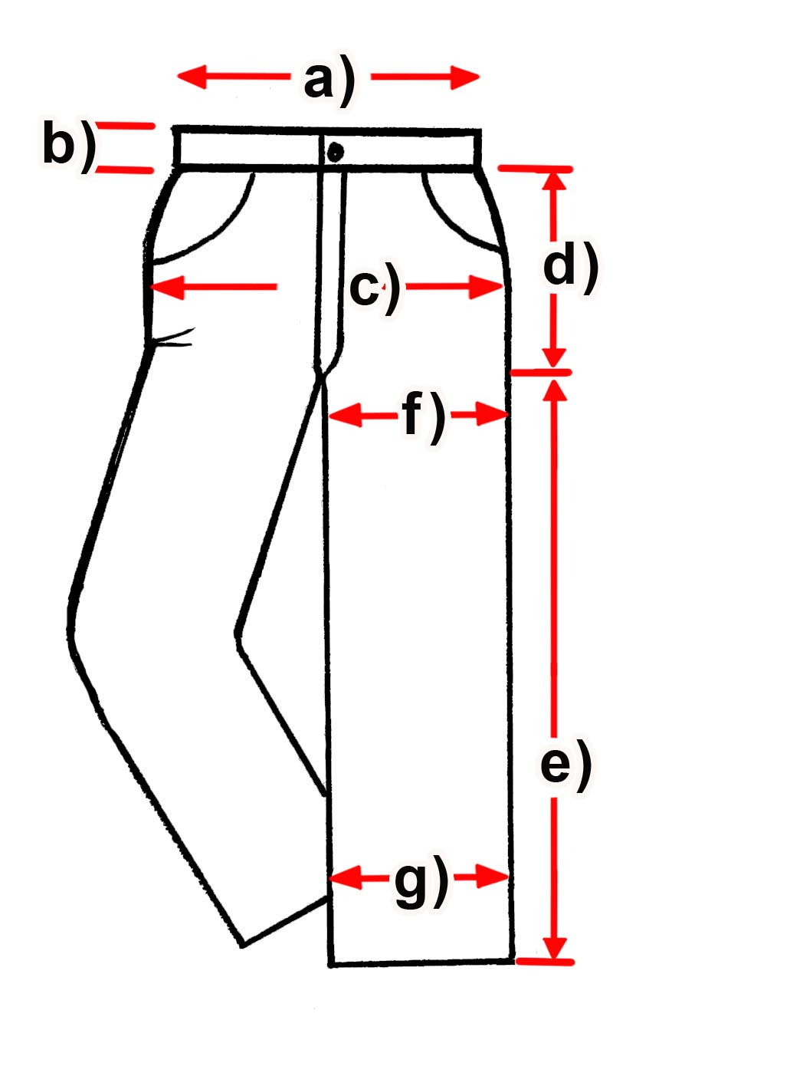

Measure (cm) | 28 | 29 | 30 | 31 | 32 | 34
a) waist width |  |  |  |  | 15 ³/4 | 16 ³/4
b) waist height |  |  |  |  | 5 | 5,7
c) Hip width |  |  |  |  | 49,5 | 52
d) Hip height |  |  |  |  | 111,7 | 112
e) Length |  |  |  |  | 83 | 84
f) Leg width above |  |  |  |  | 31,5 | 32
g) Leg width below |  |  |  |  | 19,5 | 20,5
Measure (cm) | 36 | 38 | 40 | 42 | 44 | 46
a) waist width | 18 ¼ | 19 | 20 ½ | 20 3/4 | 21 3/4
b) waist height | 5 | 5 | 5,3 | 5 | 5,5
c) Hip width | 55,5 | 57,5 | 60,5 | 61,5 | 61,5
d) Hip height | 114,5 | 116 | 117 | 117 | 118
e) Length | 83 | 84,5 | 85 | 85 | 85
f) Leg width above | 33 | 34,5 | 37 | 37,5 | 39
g) Leg width below | 23 | 23 | 24 | 24,5 | 25,5

Notes: The a) data are in inch /// 1 inch = 2,54 cm
All other data are in cm!

