**Measurements Ella**

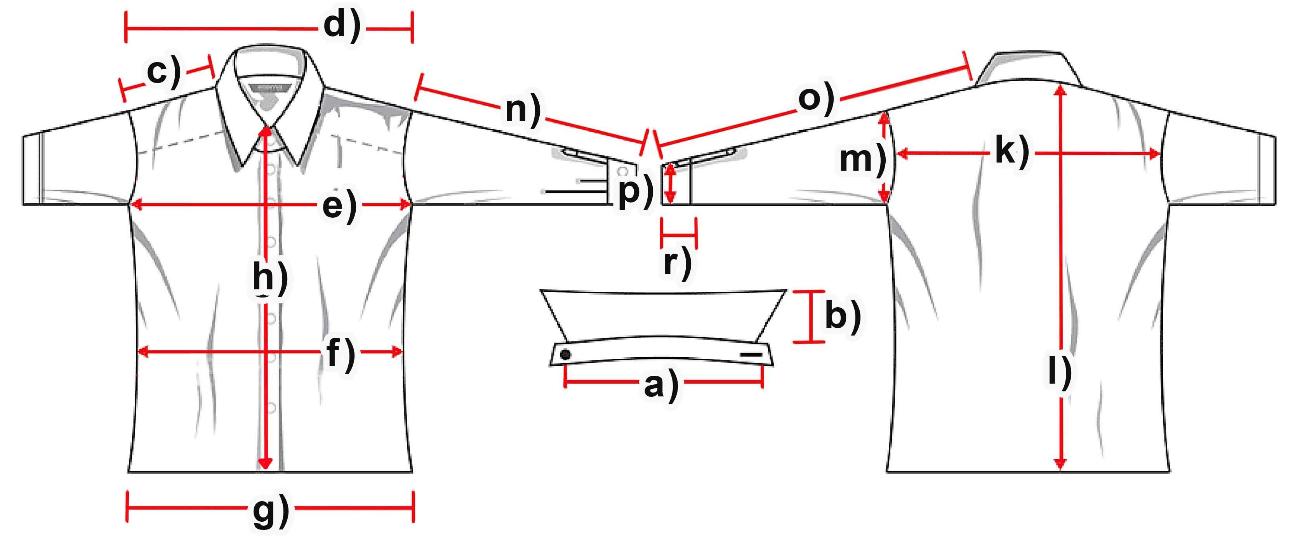

Manufacturer: Stars & Stripes _

Item: Ella _

|  |  |  |  |  |  |  |  |
| --- | --- | --- | --- | --- | --- | --- | --- |
| **Measure (cm)** | **XS** | **S** | **M** | **L** | **XL** | **XXL** | **3XL** |
| a) Collar width |  | 38,5 | 40 | 42 | 44 | 45,5 | 48 |
| b) Collar height |  | 5,2 | 5,2 | 5,2 | 5,2 | 5,2 | 5,2 |
| c) Shoulder |  | 12 | 13 | 13,5 | 14 | 15 | 15,5 |
| d) Shoulders total |  | 38,5 | 40,5 | 42,5 | 44,5 | 46,5 | 49 |
| e) Chest |  | 50,5 | 54 | 57 | 60,5 | 64 | 67 |
| f) Waist |  | 45 | 47,5 | 51,5 | 54,5 | 58,5 | 62 |
| g) Hem |  | 49,5 | 53 | 56,5 | 59,5 | 63,5 | 67 |
| h) Placket |  | 54,5 | 56,5 | 58,5 | 59,5 | 62 | 64,5 |
| k) Back width |  | 36,5 | 38,5 | 40,5 | 42,5 | 44,5 | 47,5 |
| l) Hull lenght |  | 63,5 | 65 | 67 | 70,5 | 71,5 | 74 |
| m) Armhole |  | 22,5 | 23,5 | 25 | 26 | 27 | 28 |
| n) Arm length |  | 13 | 14 | 14,5 | 15 | 16 | 16,5 |
| o) Arm + Shoulder |  | 25,5 | 27 | 28 | 29 | 31,5 | 32,5 |
| p) Cuff width |  | 18 | 18,5 | 19 | 19,5 | 20 | 21 |
| r) Cuff height |  |  |  |  |  |  |  |
|  |  |  |  |  |  |  |  |

Notes: _

_

_

_

Alteration: _

_

_

_