BRANDO

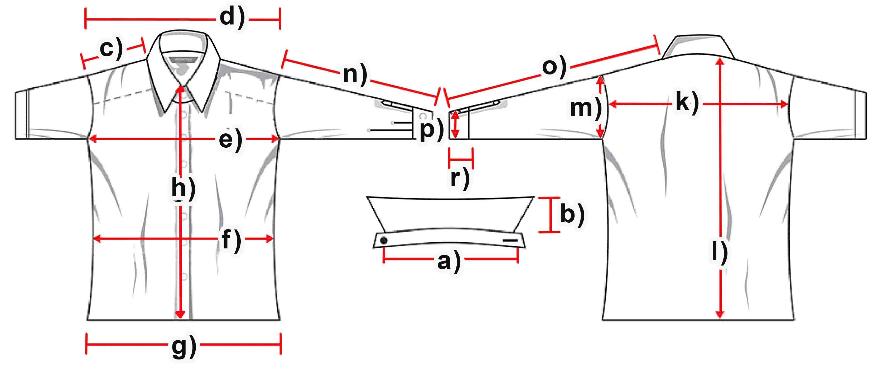

Mass (cm) | S | M | L | XL | XXL
a) collar width
b) collar height
c) shoulder | 17 | 17 | 18 | 18 | 18,5
d) shoulder complete | 51 | 51,5 | 53 | 54 | 55
e) chest | 63 | 63,5 | 65 | 66,5 | 69,5
f) waist | 59 | 59 | 60 | 62 | 64
g) hemline | 55 | 55 | 58 | 60 | 62
h) button-facing | 55 | 55 | 56,5 | 57 | 57,5
k) back | 49 | 50 | 50,5 | 50,5 | 50,5
l) length | 61,5 | 62 | 63 | 63 | 63
m)armhole | 29,5 | 30 | 30,5 | 31 | 32
n) armlength | 59 | 62 | 62,5 | 6,5 | 65
o) arm + shoulder | 76 | 79 | 80,5 | 82,5 | 83,5
p) cuff width | 14,5 | 15 | 15 | 16,5 | 17
r) cuff height | 5 | 5 | 5 | 5 | 5

